Tugas Pertemuan 5 Analisa Sistem

Level 2

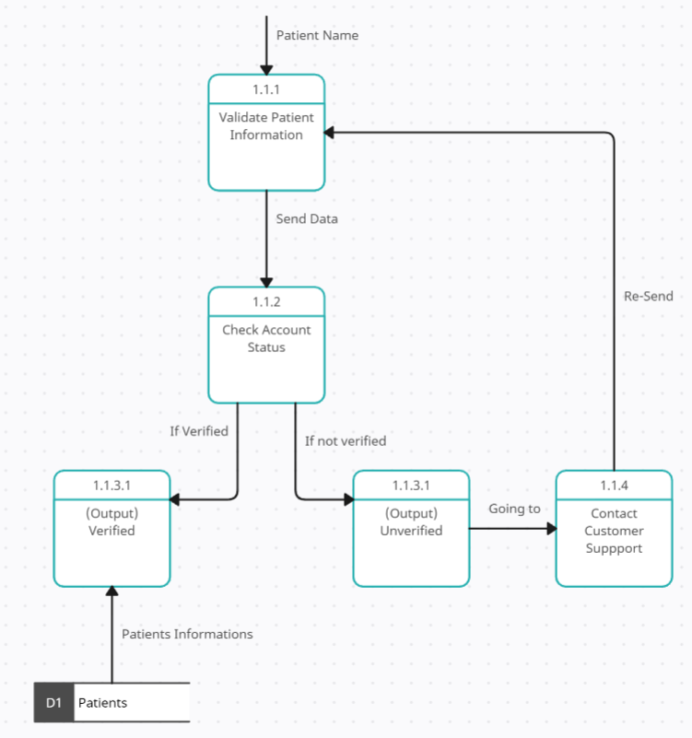

1.1.1 **Retrieve Patient Information from Database:**

* The system retrieves the patient's information from the database based on the input received from Level 1 (likely the patient's ID number or login credentials).

1.1.2 **Validate Patient Information:**

* The system verifies the retrieved patient information:
  + Checking if the ID number or login credentials match the database records.
  + Ensuring the patient's account is active and in good standing.

1.1.3 **Output:** Based on the validation results:

* **Verified Patient:** If the information is valid, the system proceeds to Level 3 (Find Possible Appointments).
* **Unverified Patient:** If the information is invalid, the system presents options:
  + Re-enter information.
  + Register as a new patient (if applicable).
  + Contact customer support for assistance.
  + Level 3

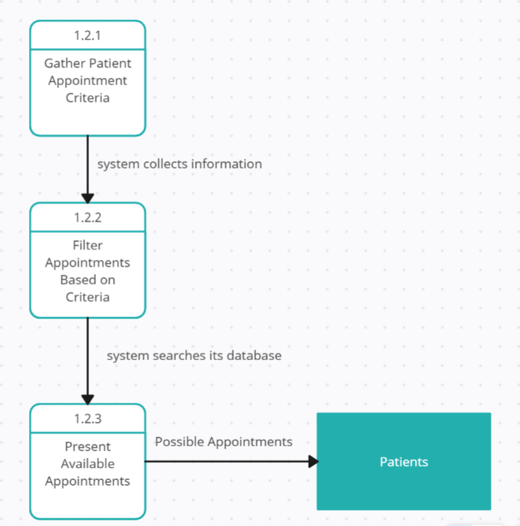

1.2.1 **Gather Patient Appointment Criteria:**

* The system collects information about the patient's desired appointment, including:
  + Preferred date(s) and time range(s).
  + Preferred healthcare provider (if known).
  + Preferred specialty (if known).
  + Preferred location (if applicable).

1.2.2 **Filter Appointments Based on Criteria:**

* The system searches its database of available appointments and filters them based on the gathered criteria.

1.2.3 **Present Available Appointments:**

* The system presents the patient with a list of filtered appointments that meet their criteria.

Level 4

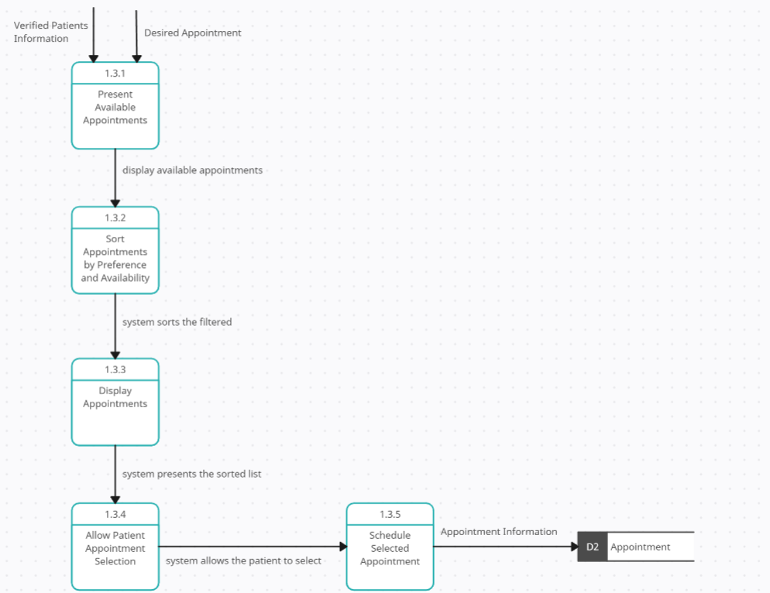

1.3.1 **Present Avaiable Appointments**

* The system display available appointments

1.3.2 **Sort Appointments by Preference and Availability:**

* The system sorts the filtered appointments from Level 3 based on factors such as:
  + Patient's preferences (date, time, provider, specialty, location).
  + Appointment availability (real-time updates).
  + Urgency (prioritizing urgent appointments).

1.3.3 **Display Appointments:**

* The system presents the sorted list of appointments to the patient.
* Each appointment should include clear information:
  + Date and time.
  + Healthcare provider name and specialty.
  + Location.
  + Any additional relevant details.

1.3.4 **Allow Patient Appointment Selection:**

* The system allows the patient to select their desired appointment from the list.

1.3.5 **Schedule Selected Appointment:**

* Once the patient selects an appointment, the system proceeds to the confirmation process